# Placebo effect of Baclophen

## The data

The original dataset was transformed in a data set with the following columns:

* EAD.nummer: identifies the patient
* Dag: test day from 1 to 5
* Dosis: dose given on each day
* VorigeDosis: the dose given on the day before. (zero for day 1)
* DosisEergisteren: the dose given 2 days before.
* TijdNaInj: time after injection when MAS score was determined (2 or 4 hours)
* MAS.effect: The difference between Masna2uur or Masna4uur and MASvoor for TijdNaInj of 2 or 4 hours, respectively.

## Data exploration.

Before doing regressions just have a look at the data. Figure 1 shows a plot for each patient with the effect on the MAS score. The effect the difference in MAS score after and before the injection. Most patients have a negative trend, so a lower MAS score for higher doses. Baclophen works ☺. The intercept of the regression line for both 2 and 4 hours after the injection is close to zero. For most of the patients the confidence interval around the regression line contains zero. This means that for a dose of zero there is no effect, i.e. no placebo effect.

Figure 2 shows this in another way. For each patient a linear regression was done between MAS.effect and dose. Time after injection and previous doses were not taken into account. The intercept and slope and their respective confidence intervals were calculated. Figure 2 shows a box plot of the intercepts and slopes. Dots are red when zero was not in the 95% confidence interval (significant) and blue when zero was inside the confidence interval. Most intercepts are not significant, indicating that there is no placebo effect. Most slopes are significantly negative, indicating that baclophen decrease the MAS score.

D:\Other\ITB\Overzicht_dosis_effect_per_patient_all_20170831.tiff

Figure : Overview of individual baclophen trials. Effect of 2 or 4 hours depending on the dose.

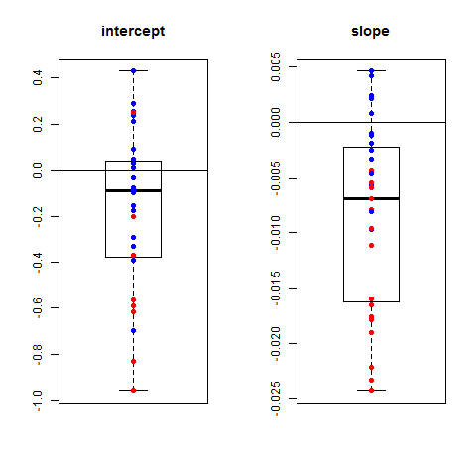

Figure 2: Box plots of the intercept and the slope of a regression line for each patient. Red dots are significantly different from zero, blue ones not

## Multiple linear regression

With a multiple linear regression the effect of the dose, the time after injection, and the doses of the previous two days on the MAS score of the patient. This is the regression model:

MAS.effect ~ Dosis + TijdNaInj + vorigeDosis + DosisEergisteren

The table below gives the result:

Coefficients:

Estimate Std. Error t value Pr(>|t|)

(Intercept) -0.1132756 0.1334642 -0.849 0.39680

Dosis -0.0060867 0.0009521 -6.393 7.3e-10 \*\*\*

TijdNaInj -0.0622253 0.0373753 -1.665 0.09712 .

vorigeDosis 0.0066979 0.0025714 2.605 0.00971 \*\*

DosisEergisteren -0.0077385 0.0023965 -3.229 0.00140 \*\*

---

Signif. codes: 0 ‘\*\*\*’ 0.001 ‘\*\*’ 0.01 ‘\*’ 0.05 ‘.’ 0.1 ‘ ’ 1

The intercept and the time after injection are not significant. Hence, there is no placebo effect and measuring twice after the injection might not be necessary. But are the assumptions of a multiple linear regression fulfilled?

Check if the residuals are independent? Figure 3 shows that the residuals of the linear regression are not randomly distributed around zero for each patient. For some patients all residuals are positive or negative. Hence, a linear regression cannot be used. A linear mixed model with a random effect per patient has to be fitted.

D:\Other\ITB\residuals_linear_regression_full_model.tiff

Figure 3: Box plots of the residuals per patient of a linear regression.

## Linear mixed model

The following mixed model was fitted:

MAS.effect ~ Dosis + vorigeDosis + DosisEergisteren + TijdNaInj + (Dosis | EAD.nummer)

There is an individual intercept and slope for each patient. Both are distributed randomly around a group intercept and slope. The result is:

|  |
| --- |
| Linear mixed model fit by REML ['lmerMod']  Formula: MAS.effect ~ Dosis + vorigeDosis + DosisEergisteren + TijdNaInj + (Dosis | EAD.nummer)  Data: itb.effect  REML criterion at convergence: 441.8  Scaled residuals:  Min 1Q Median 3Q Max  -3.1931 -0.5633 0.0766 0.6444 3.3419  Random effects:  Groups Name Variance Std.Dev. Corr  EAD.nummer (Intercept) 7.073e-02 0.265954  Dosis 4.271e-05 0.006535 -0.15  Residual 1.875e-01 0.433028  Number of obs: 270, groups: EAD.nummer, 31  Fixed effects:  Estimate Std. Error t value  (Intercept) 0.040935 0.110721 0.370  Dosis -0.008545 0.001431 -5.972  vorigeDosis 0.003997 0.001989 2.009  DosisEergisteren -0.006462 0.001854 -3.485  TijdNaInj -0.052000 0.027094 -1.919  Correlation of Fixed Effects:  (Intr) Dosis vrgDss DssErg  Dosis -0.290  vorigeDosis -0.233 0.047  DossErgstrn 0.102 0.010 -0.925  TijdNaInj -0.716 0.017 -0.007 0.013 |

The intercept is not significant because the t-value lies between -2 and 2. So the intercept could be removed from the model. Also the previous doses and time-after-injection are not very significant.

The residuals per patient are better centered on zero.

D:\Other\ITB\residuals_linear_mixed_model.tiff

A linear mixed model without intercept, before yesterday’s dose and time-after-injection

|  |
| --- |
| Linear mixed model fit by REML ['lmerMod']  Formula: MAS.effect ~ 0 + Dosis + vorigeDosis + (Dosis | EAD.nummer)  Data: itb.effect  REML criterion at convergence: 438.5  Scaled residuals:  Min 1Q Median 3Q Max  -2.7406 -0.4998 0.0107 0.5265 3.7042  Random effects:  Groups Name Variance Std.Dev. Corr  EAD.nummer (Intercept) 7.979e-02 0.282470  Dosis 4.511e-05 0.006716 -0.18  Residual 1.961e-01 0.442864  Number of obs: 270, groups: EAD.nummer, 31  Fixed effects:  Estimate Std. Error t value  Dosis -0.0089796 0.0013340 -6.731  vorigeDosis -0.0027333 0.0006681 -4.091  Correlation of Fixed Effects:  Dosis  vorigeDosis -0.083 |

The dose of the previous day has an effect that is 3 times smaller than the dose of the same day.

Measuring after 2 or 4 hours? The difference is not significant for the whole population but the figure below shows that the effect after 2 hours is similar or sometimes bigger than after 4.

